“AI IN SMART-HOME”
Report

SUBMITTED BY:

Vikash Pandey 12106224 RK21ANB67
Arnab Sarkar 12105922 RK21ANA19
Araman Kumar 12111817 RK21ANB43
Section: K21AN

SUBMITTED TO:
Ankita Wadhawan mam


School of computer science and engineering
Lovely Professional University
Phagwara, Punjab (India)

TITLE:- ARTIFICIAL INETELLIGENCE IN SMART HOME

1)ABSTRACT
Smart house and artificial intelligence technologies are evolving rapidly, and various smart home goods related with artificial intelligence (AI) improved the quality of living for occupants. Although various research investigated the use of artificial intelligence in smart homes, few publications examined the integration of books and goods in depth. We hope to answer the study questions "what is the trend of smart home technology and products" and "what is the relationship between literature and products in smart homes with AI" in this paper. To explain the functions and roles of artificial intelligence in smart homes, literature evaluations and product reviews are provided. We established the application status of artificial intelligence in smart home devices and how it is used in our home so that we could understand how artificial intelligence is used to create smart homes. Furthermore, our findings revealed that there is a lag between literature and products, and smart home intelligent interactions will become increasingly popular.

2)INTRODUCTION
The advancement of smart home technology has aided in the transformation of the traditional home into a smart internet-connected one. A smart home is a dwelling that is outfitted with technology such as sensors, wired and wireless networks, actuators, and intelligent systems. Smart houses, which are outfitted with cutting-edge automation technologies, can monitor and control home activities for convenience, improve tenant comfort, and possibly reduce energy consumption .Data from the household environment is collected and analyzed by smart home technologies. It also communicates information to users and improves the capability of handling various home systems.
As we have learnt in our AI course , Artificial intelligence (AI) refers to any equipment that understands its environment and takes activities to maximize its chances of success. The ideal state of artificial intelligence is to think humanly, rationally, humanely, and rationally.
All technology is employed in smart home gadgets. We established six basic clusters of AI tasks in smart homes for ease of understanding: activity recognition, data processing, speech recognition, picture recognition, decision-making, and prediction-making. In terms of activity recognition, smart home devices can use AI to recognize human activity.
It analyses sensor data to recognize human actions and sounds an alarm if there is any unusual activity. Hive Link and Essence Care @ Home use activity recognition. In terms of data processing, AI is based on data analysis techniques that extract information from various data sources and uncover fundamental links. In the aspect of voice recognition, AI works based on voice-driven technologies, and allows people to interact with it simply by having a conversation, for instance, asking about the weather, ordering products online, or calling a cab. Voice recognition is used in Amazon Alexa, Google Home, etc. In the aspect of image recognition, AI is used to achieve facial recognition, emotion recognition, biometrics, and scene understanding. It can measure and analyze human behavior, as well as physical aspects of the body’s structure and form. It is used in Lighthouse, Nest Cam, Honeywell Smart Home Security System, Tend Secure Lynx Indoor Camera, Canary All-In-One, Netatmo Welcome Indoor Security Camera, etc. In the aspect of decision-making, AI plays the role of the decision-maker. It can decide what action should be taken in response to the input data.
Many smart home gadgets and solutions are available, but only for lower levels of interaction, such as devices for establishing environmental parameters and house management. However, there have been a few attempts to construct the most advanced level of a smart house.

3)ANALYSIS OF APPLICATION OF AI IN SMART HOME
There were multiple steps in the qualitative inductive technique. We derived five fundamental functionalities of smart home , including device management, energy management, healthcare, intelligent interaction, and security. Tang highlighted that intelligent buildings used expert systems, artificial neural networks, and intelligent decision-making systems . Based on that, we divided the AI operations in smart homes into six clusters, That is, activity detection, data processing, decision-making, picture recognition, prediction-making, and voice recognition are all examples of machine learning. Data processing in this article comprises data mining, semantic analysis, and rule-based systems.
We derived six functionalities of goods with AI in smart homes from the product review, including energy management, entertainment system, healthcare, personal robot, intelligent interaction, and security. Following that, we classified them into six groups: activity recognition, data processing, decision-making, image recognition, prediction-making, and voice recognition.
Then , we conducted a quantitative study of the quantity of items in each category under books and products.
- Home Automation: AI-powered smart home systems can control the lighting, temperature, and other gadgets in your home automatically. You can, for example, program your home thermostat to turn off the heating or cooling when you leave and turn it back on when you return.
- Voice-Activated Assistants: Artificial intelligence-based virtual assistants such as Amazon's Alexa, Google Assistant, and Apple's Siri can be linked with smart home systems to operate gadgets by voice commands. With speech-activated assistants, you may use a simple spoken command to turn on/off lights, control the thermostat, play music, or even order groceries.
- Security and Surveillance: Artificial intelligence-powered security cameras and sensors can detect odd activity and provide notifications to homeowners. AI-powered security cameras, for example, can tell the difference between a pet and an invader.
- Energy Management: AI-powered smart home systems can analyze energy use patterns and make energy-saving adjustments to heating and cooling systems. For example, the system can automatically switch off lights and devices when they are not in use or alter the temperature based on occupancy.
- Personalization: AI-powered smart home systems can learn and adapt to your tastes. When you return home, for example, the system can adapt the lighting and temperature to your usual settings, or even suggest recipes based on your eating preferences.
To summarize, AI technology is revolutionizing the way we engage with smart homes by offering homeowners with personalized and efficient solutions.
In below image we have shown the growing of AI in smart home globally through the graph .
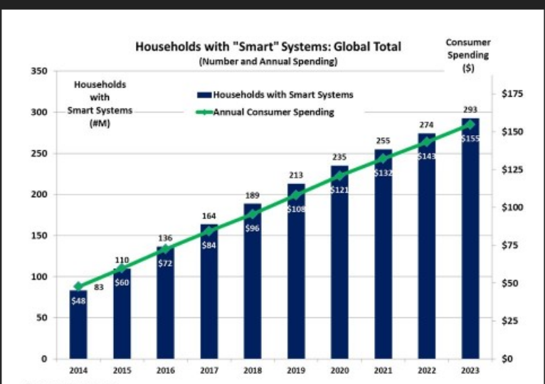
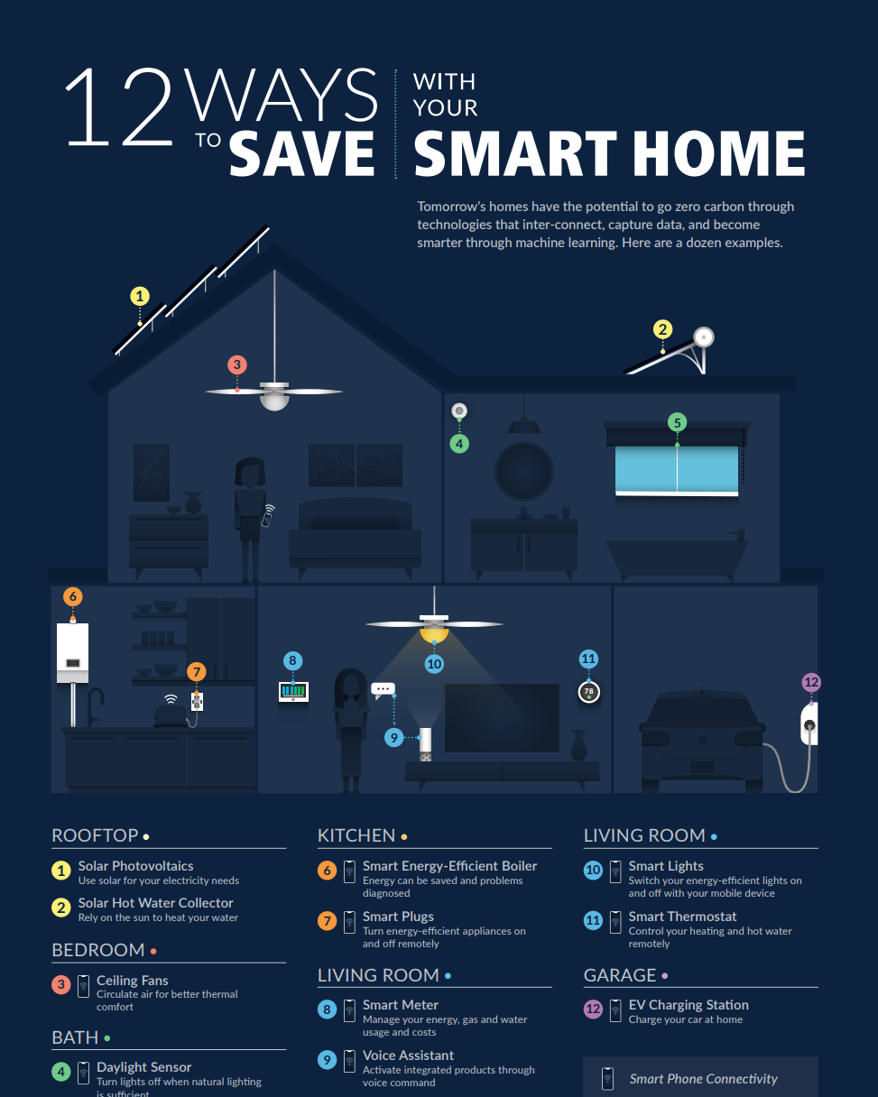

4)PROS AND CONS OF AI IN SMART HOME
PROS:-
AI-powered devices can automatically change lighting, temperature, and other home equipment. This can save time and eliminate the need for manual adjustments.
- Energy efficiency: Artificial intelligence can optimize energy consumption by analyzing user habits and modifying energy consumption accordingly. For example, AI can identify when a room is vacant and turn off lights and appliances automatically, which can help cut energy expenses.
- Increased safety: AI-powered smart houses can monitor their surroundings and notify homeowners of potential threats such as gas leaks or fires. They can also send alerts when there is odd activity or unauthorized entry, which improves home security.
- Personalization: Over time, AI systems can learn from user behavior and adapt to individual preferences. This can result in a more personalized and targeted experience for each individual user.
CONS:-
- Concerns about privacy: To work successfully, smart homes rely on vast volumes of data, including personal and sensitive information. Concerns have been raised concerning how this data is collected, stored, and used, as well as its vulnerability to hackers or misuse.
- Technology reliance: Smart homes rely significantly on technology, and if the technology fails, the home may not work effectively. This can be especially troublesome if the homeowner is not tech-savvy, or if there is a power loss or internet outage.
- Cost: The cost of building and maintaining an AI-powered smart home can be rather significant, making it out of reach for many homeowners. Furthermore, the expense of fixing or replacing smart home gadgets can be prohibitively high.
- Limited compatibility: Smart home gadgets from different manufacturers may be incompatible with one another, making integration and control difficult through a single AI-powered system. This can limit smart home capabilities and result in a fragmented user experience.
5)REVIEWS
• AI technology has significantly advanced in recent years, and its use in smart homes is becoming increasingly popular. By leveraging AI algorithms, smart homes can optimize energy consumption, enhance security, and improve the overall comfort and convenience of living spaces.
• The implementation of AI in smart homes requires various interconnected technologies, such as sensors, data analytics, and machine learning algorithms. When integrated correctly, these technologies can provide a seamless and efficient experience for homeowners, allowing them to control and monitor their homes remotely and autonomously.
• However, the implementation of AI in smart homes also raises concerns about data privacy and security. With the large amount of data generated by smart homes, it is crucial to ensure that this data is collected and stored securely to prevent unauthorized access and potential breaches.
• Overall, the use of AI in smart homes is a promising development that has the potential to revolutionize the way we live. However, it is important to address potential privacy and security concerns and ensure that the benefits of AI are balanced with its potential risks.

6)RESULTS
We found all condition and applicable work of ai in smart home ,ai makes all the work easy in home.
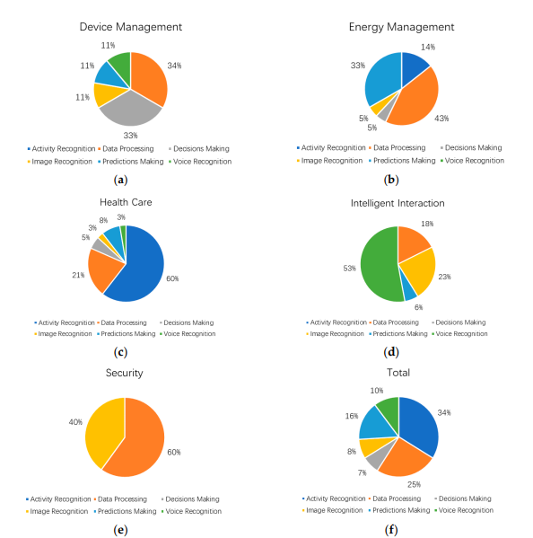 figure 2. (a) Artificial intelligence (AI) functions in device management; (b) AI functions in energy management; (c) AI functions in healthcare; (d) AI functions in intelligent interaction; (e) AI functions in security; (f) AI functions in all functions of smart homes.

EXAMPLE:-
6)i)WORKING MODAL OF ALEXA IN SMART HOME:-
The working model of Alexa in a smart home involves several components working together to enable voice control of smart home devices. Here is a brief overview of how Alexa works in a smart home:
Smart home devices: Alexa is compatible with a wide range of smart home devices, including smart lights, thermostats, locks, and appliances. These devices must be connected to your home Wi-Fi network and compatible with the Alexa app.
Alexa device: You'll need an Alexa-enabled device, such as an Amazon Echo or Echo Dot, to communicate with your smart home devices. These devices use far-field voice recognition technology to listen for and respond to voice commands from across the room.
Alexa app: The Alexa app is used to set up and manage your smart home devices. Through the app, you can add new devices, create routines, and manage device settings.
Skills: Alexa skills are voice-activated apps that allow you to control third-party devices and services through Alexa. For example, you can use the "Nest" skill to control your Nest thermostat through Alexa.
Voice commands: Once your smart home devices are set up and connected to Alexa, you can use voice commands to control them. For example, you can say "Alexa, turn on the living room lights" or "Alexa, set the temperature to 72 degrees."
Routines: Routines allow you to automate multiple smart home devices with a single voice command. For example, you could create a routine called "bedtime" that turns off all the lights and locks the doors when you say "Alexa, bedtime."
Overall, the working model of Alexa in a smart home involves integrating smart home devices with Alexa, enabling voice control through an Alexa-enabled device, and using the Alexa app to manage and customize your smart home experience.

7) THE DATASET USED TO DEMONSTARTE THE USE CASE FOR “AI IN SMART-HOME”
More application cases surface as both AI and smart home technologies develop. It's great to see how home automation may make life simpler for homeowners or any person since it appears like more possibilities are opening up.
Consider a scenario where someone is using a smart cooktop to cook. In such situation, an AI device may keep track of the food's cooking temperature and adjust the temperature for the best results.
Another point can be as: that AI systems will have the knowledge and capability to keep the light ,fan ,air conditioner systems off until the door opens if they detect that no one is at home.
Then, these units will switch on when AI devices detect that the any person or homeowner has returned. AI and smart home technology may be used to automate jobs, make choices, and provide homeowners with the best possible living circumstances. AI technology can control many daily tasks in a home by acting as an external brain / duplicate brain of ours.
Smart Home Energy Dataset: This dataset includes information on the amount of power used by 8 households over the course of two to three years. The dataset may be used to train AI models that forecast energy use and point out areas where energy might be saved in smart homes.
Home Activities Dataset: This set of sensor data from smart homes includes details about the usage of various appliances, the use of specific rooms, and the on/off switching of various lights. The home environment may be modified to improve comfort and energy efficiency using AI models trained on this data to identify trends in household activity .Voice Command Dataset: This set of data includes recordings of voice commands uttered to Google Home and Amazon Echo smart home appliances.
To enable hands-free operation of smart home devices, the dataset may be used to train AI models to detect and react to voice requests.

Monitor condition
User

<<Extend>>
Service Database
Control home access
Control Appliance

<<Extend>>

<<Extend>>

Request service
Control ac fan

Control lights
Condition acuator
<<include>>
Read analog ports
Read server

Read digital ports

Senser/Acuator

<<include >>implicit function(compulsory)
<<extend>>explicit function(optional)

8)GANTT CHART

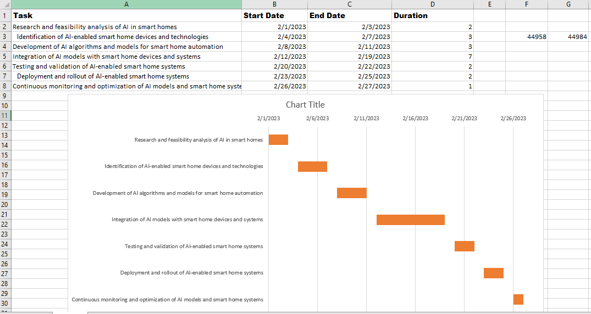

9)CONCLUSION
The purpose of this study was to discover how AI makes homes smarter. Many studies in the literature and various items were reviewed to reach this goal. We discovered that using activity recognition, data processing, decision-making, image recognition, prediction-making, and voice recognition, AI technology aids smart homes in device management, energy management, healthcare, intelligent interaction, security, entertainment systems, and personal robots. There is a gap between the literature and the products, with the latter focusing on relatively easy approaches such as picture recognition and speech recognition.
AI with voice and image recognition is widely used in smart home products, while the technologies of activity recognition, data processing, and prediction-making still need to be developed. In the predictable future, smart homes will pay more attention to the interaction between people and the environment to make buildings more sustainable and personalized.
One important future direction in applying AI to smart homes is considering both smart home technology and architecture design and developing relevant standards.

10)REFERENCES
Risteska Stojkoska, B.L.; Trivodaliev, K.V. A Review of internet of things for smart home: Challenges and solutions. J. Clean. Prod. 2017, 140, 1454–1464.
Huh, J.; Seo, K. Lecture notes in electrical engineering. In Artificial Intelligence Shoe Cabinet Using Deep Learning for Smart Home.
Jivani, F.D.; Malvankar, M.; Shankarmani, R. A Voice controlled smart home solution with a centralized management framework implemented using AI and NLP(Natural Language Processing). In Proceedings of the 2018 International Conference on Current Trends towards Converging Technologies (ICCTCT), Coimbatore, India, 1–3 March 2018.
Raeiszadeh, M.; Tahayori, H. A Novel method for detecting and predicting resident’s behavior in smart home. In Proceedings of the 2018 6th Iranian Joint Congress on Fuzzy and Intelligent Systems (CFIS) Kerman, Iran.
Jithish, J.; Sankaran, S. A Hybrid adaptive rule based system for smart home energy prediction. CEUR Workshop Proc. 2017, 1819.
Vastardis, N.; Kampouridis, M.; Yang, K. A user behaviour-driven smart-home gateway for energy management. J. Ambient Intell. Smart Environ. 2016.
Artem, K.; Vasyl, T. Structure and model of the smart house security system using machine learning methods. In Proceedings of the 2017 2nd International Conference on Advanced Information and Communication Technologies (AICT) IEEE, Lviv, Ukraine, 4–7 July 2017.
Durand, A.; Ngoko, Y.; Cerin, C. Distributed and in-situ machine learning for smart-homes and buildings: Application to alarm sounds detection. In Proceedings of the 2017 IEEE International Parallel and Distributed Processing Symposium Workshops (IPDPSW), Lake Buena Vista, FL, USA, 29 May–2 June 2017.
You-tube animation video link:- https://youtu.be/_w6-xDa4xgs

THANKS

